# Q1: How long did the game engage you?

# Q2: How fun is the game? Rate from 1-10 where 10 is the most fun.

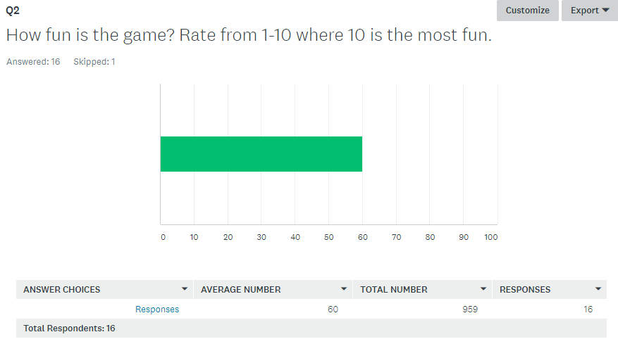

# Q3: Were there any issues with the controls?

1. No
2. Yes, the shooting is not smooth, when I hit the enter button, sometimes the fireball comes out, other times it doesn’t and sometimes it gets spammed. Feels really un-natural. Is the jumping using gravity?
3. Jumping mechanics is not responsive
4. Controls are awkward with enter as shooting and P as the charged shot. Sometimes can't jump near the edge while moving.
5. The jump doesn't feel like a curve, need better camera also
6. Yes, controls feels all over the place. Space to jump, enter to fire.
7. Nope
8. The jumping was a little buggy
9. Controls are weird. Sometimes cannot jump while moving.
10. Controls are weird. Sometimes cannot jump while moving.
11. Yes, the character is unable to jump vertically
12. The spacebar for jump has delay, which is annoying.
13. Jumping is stiff, control scheme could be a little more streamlined.
14. Yes, controls feels all over the place. Space to jump, enter to fire.
15. Jumping. I have to wait for some millisecond before I can jump again. Feels not really responsive.
16. Delay between jumping intervals are a bit too long
17. Controls were too rigid for me

Overall feedback has to do with the queue system we are using for the controls which affects the delay between jumps and some issues with attacking.

# Q4: Were there any issues with the interface?

1. yes
2. There was no health bar and overall no user interface
3. I cannot see the HP of enemy and could not get feedback on the boss
4. The dragon is still on a platform even when it’s completely empty below. Kind of hard to tell the mega charge attack, maybe add a visual cue or something
5. need build up to know when is mega fire
6. Need more work on the UI. I don't know when I can use the big fireball
7. Nope
8. Nope
9. Tutorial needs more explanation(At the start of the game)
10. Tutorial needs more explanation(At the start of the game)
11. interface was ok
12. The health hearts HUD could be more obvious.
13. Camera follows player too closely.
14. Background missing textures. showing white background
15. Maybe can add the charge meter bar because of I don’t know how much I need to fully charge again. HP a bit buggy.
16. Nope
17. camera

The health needs to be more obvious. Consider changing the displaying of the charge for mega fireball into a clearer charge bar/particles? Camera needs some work, some said it followed too closely.

# Q5: Do you know the main objective of the game? If yes, list the objective. If No, explain why.

15 yes, 2 no

1. No, it wasn’t explained clearly at the start of the game.
2. No. The first impression was to head wherever there are enemies.

# Q6: Note something you liked about the game.

1. the mega fireball
2. The concept of the signboard tutorials was interesting and well implemented.
3. I like how engaging the game in the battles.
4. The boss fight was pretty cool.
5. fat
6. Mario but dragon.
7. The theme of the game and the animation
8. The sounds
9. Idea is good
10. Idea is good
11. I <3 KA
12. The boss fight.
13. Boss has interesting mechanics and I like the fact that some platforms can be passed through from the bottom.
14. the music
15. Cool art.
16. game is funny

# Q7: Note things you disliked about the game.

1. how the camera follows the player
2. The jumping is extremely unnatural. Overall the controls are very clunky and unresponsive.
3. Jumping is a chore and feels slippery.
4. Clunky movements
5. level design, I didn't have mega fire when I reach the first tower, need more indication/feedback when enemy get damage, dino was too fat that it couldn't go down some hole
6. Poor feedback on the attacks and the game metric for the jump needs to be looked at.
7. Not enough feedback. Player jump feels unresponsive.
8. The jumping is a little unresponsive
9. Mobs too simple. Easy to trick
10. Mobs too simple. Easy to trick
11. the camera movements creates discomfort in my eyes
12. The super fire "p" button, not very useful.
13. Camera and controls as mentioned above.
14. the controls
15. Maybe better design. Nicer textures. Improve gameplay mechanics? Like more responsive controls. Better level design? All this is changes. lol
16. Jumping did not feel intuitive. Enemies were pretty easy to kill. Boss level was quite easy too.
17. player control

Most disliked how the jumping works, the clunky movement and the mega fireball wasn’t very useful. Level design for level 1 also needs to be looked at and re-designed.

# Q8: What changes would you like the see?

1. The game would be more interesting if there would be more unique selling points to make the game stand out from the other platform games. To be more specific, maybe the player speed can be faster to make it harder for the player to control; there could be more traps to slower down the player's movement and get higher damage. Low difficulty of the game may make the player feel bored sometimes. In terms of the UI, maybe there could be some instructions on how to get the mega fire ball (e.g. how many normal hits will activate this).
2. Please make the controls smooth. The game lacks action for an action plat-former. Feels more like a slow paced RPG.
3. Slow down the game a little bit and implement visual feedback for enemy
4. More visual feedbacks
5. thinner, better controls and camera, more feedback
6. Add feedback on the attacks and then improve the game metric for the jump.
7. Add more abilities and power up
8. More abilities maybe
9. Saber Alter, alteria, gilgamesh, lancelot
10. Make the "p" bullet look different from the "enter" bullet.
11. More enemy AI and better controls/camera. More animations
12. better controls
13. the above
14. More challenging enemies. Use different indicators for power up attacks,
15. make player control more smooth

Main changes include having more content, smooth controls and more visual feedback.